**Spike:** Spike 22

**Title:** Spike Collisions

**Author:** Bernardo Fitzmaurice Acevedo 105297603

**Goals / deliverables:**

The goal of this spike is to create 2D entities, being able to implement collision on those same entities and to switch the entities shape in any part of the execution.

Besides this report, what else was created?

* A C++ project containing:
  + Main.cpp
  + A Box class. (.cpp and .h files)
  + A Circle class. (.cpp and .h files)
  + A Collision class. (.cpp and .h files)
* 2 images for the circles.

**Technologies, Tools, and Resources used:**

* Visual Studio 2022
* SDL2 version 2.30.8
* SDL2 image version 2.8.2
* Lazy Foo documentation.
* 2 images of a circle or similar.

**Tasks undertaken:**

* Download and install VS Community 2022.
* Download SDL2 and SDL2 image and install them on your windows hard drive or SSD.
* Create C++ project.
* From “project properties” create a path to SDL2 libraries.
* Create the main.cpp
* Create “Box” class:

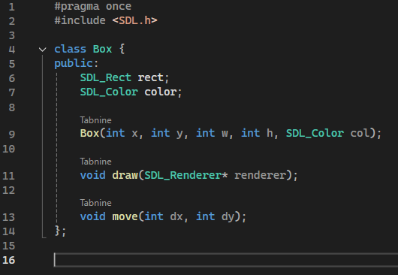.h file

* Create “Circle” class:

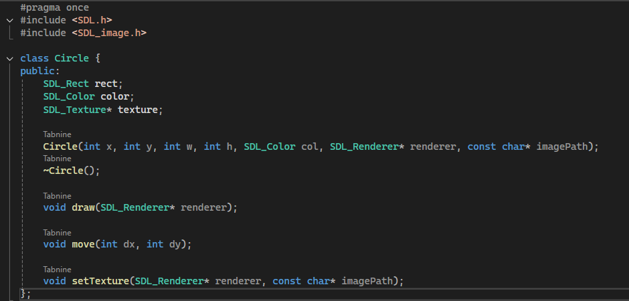.h file

* Create “Collision” class:

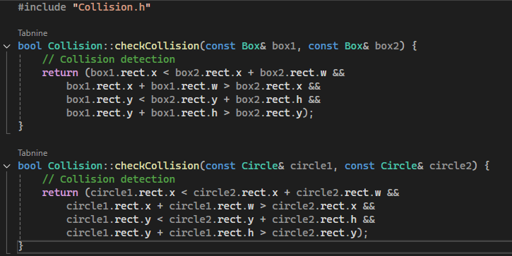.cpp file

* Compile code:

Result box

Result circle (lol)

**What we found out:**

During this task I learned how to apply collisions to objects and how to change those objects without losing the collision but modifying it to match with the new shape.

